**PL/SQL programming**

Exercise 1: Control Structures

Coding:

CREATE TABLE customers (

customer_id INT PRIMARY KEY,

age INT,

interest_rate DECIMAL(5,3),

balance DECIMAL(10,2),

isvip BOOLEAN DEFAULT FALSE

);

CREATE TABLE loans (

loan_id INT PRIMARY KEY,

customer_id INT,

due_date DATE,

FOREIGN KEY (customer_id) REFERENCES customers(customer_id)

);

INSERT INTO customers VALUES

(101, 58, 0.075, 8000, FALSE),

(102, 62, 0.080, 12000, FALSE),

(103, 66, 0.065, 9500, FALSE),

(104, 45, 0.070, 15000, FALSE);

INSERT INTO loans VALUES

(201, 101, CURDATE() + INTERVAL 10 DAY),

(202, 102, CURDATE() + INTERVAL 28 DAY),

(203, 103, CURDATE() + INTERVAL 40 DAY);

**1.Scenario:**

UPDATE customers

SET interest_rate = interest_rate - 0.01

WHERE age > 60;

**2.Scanerio:**

UPDATE customers

SET isvip = TRUE

WHERE balance > 10000;

**3.Scenario:**

SELECT loan_id, customer_id, due_date,

CONCAT('Reminder: Loan ', loan_id, ' for Customer ', customer_id, ' is due on ', DATE_FORMAT(due_date, '%d-%b-%Y')) AS ReminderMessage

FROM loans

WHERE due_date BETWEEN CURDATE() AND CURDATE() + INTERVAL 30 DAY;

Output:

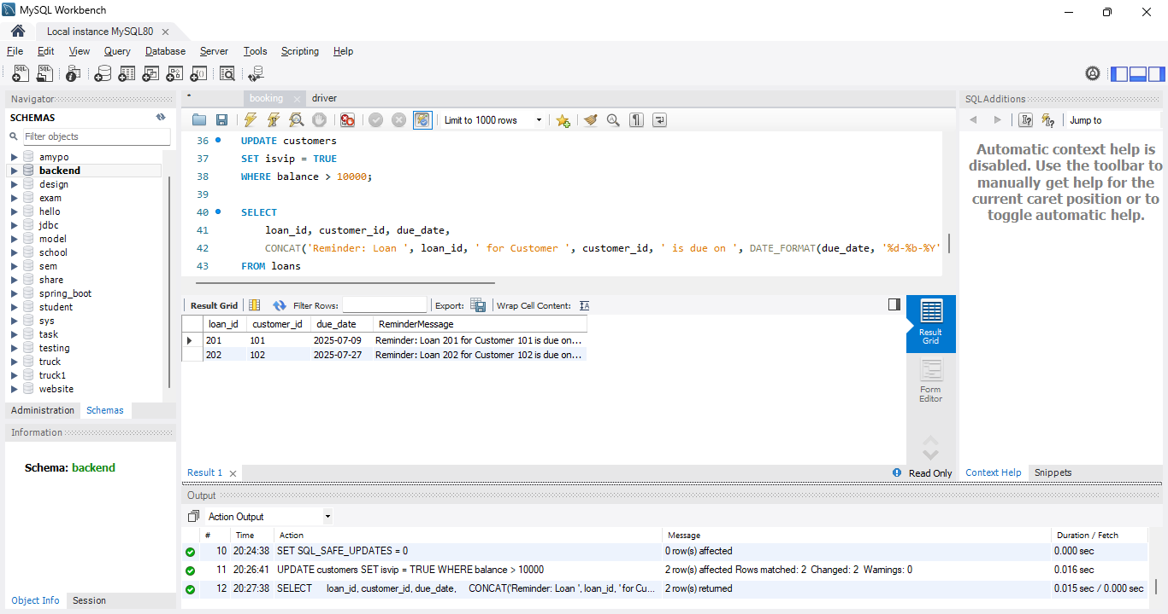

Exercise 3: Stored Procedures

Coding:

CREATE TABLE savings_accounts (

account_id INT PRIMARY KEY,

balance DECIMAL(12,2)

);

INSERT INTO savings_accounts VALUES (1, 1000), (2, 1500), (3, 2000);

CREATE TABLE employees (

emp_id INT PRIMARY KEY,

name VARCHAR(100),

department_id INT,

salary DECIMAL(10,2)

);

INSERT INTO employees VALUES

(1, 'Alice', 10, 50000),

(2, 'Bob', 10, 55000),

(3, 'Charlie', 20, 60000);

CREATE TABLE accounts (

account_id INT PRIMARY KEY,

customer_id INT,

balance DECIMAL(12,2)

);

INSERT INTO accounts VALUES

(1, 101, 5000),

(2, 101, 2000),

(3, 102, 1000);

1.Scenario:

DELIMITER $$

CREATE PROCEDURE ProcessMonthlyInterest()

BEGIN

UPDATE savings_accounts

SET balance = balance + (balance * 0.01);

END$$

DELIMITER ;

SELECT * FROM savings_accounts;

Output:

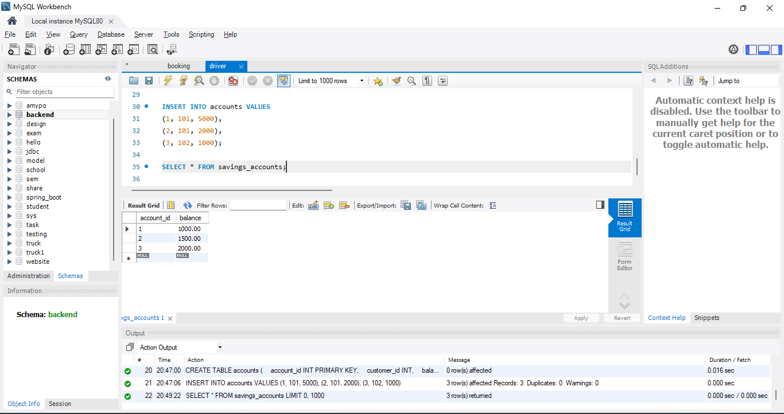

2.Scenario:

DELIMITER $$

CREATE PROCEDURE UpdateEmployeeBonus(

IN dept_id INT,

IN bonus_percent DECIMAL(5,2)

)

BEGIN

UPDATE employees

SET salary = salary + (salary * bonus_percent / 100)

WHERE department_id = dept_id;

END$$

DELIMITER ;

SELECT * FROM employees;

OUTPUT:

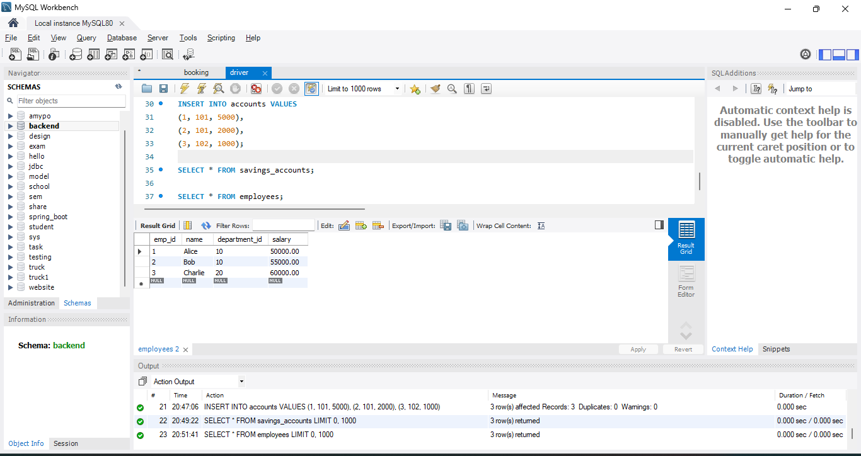

3.Scenario:

Coding:

DELIMITER $$

CREATE PROCEDURE TransferFunds(

IN from_account INT,

IN to_account INT,

IN amount DECIMAL(10,2)

)

BEGIN

DECLARE from_balance DECIMAL(12,2);

SELECT balance INTO from_balance

FROM accounts

WHERE account_id = from_account;

IF from_balance >= amount THEN

UPDATE accounts

SET balance = balance - amount

WHERE account_id = from_account;

UPDATE accounts

SET balance = balance + amount

WHERE account_id = to_account;

ELSE

SIGNAL SQLSTATE '45000'

SET MESSAGE_TEXT = 'Insufficient balance for transfer';

END IF;

END$$

DELIMITER ;

SELECT * FROM accounts;

Output:

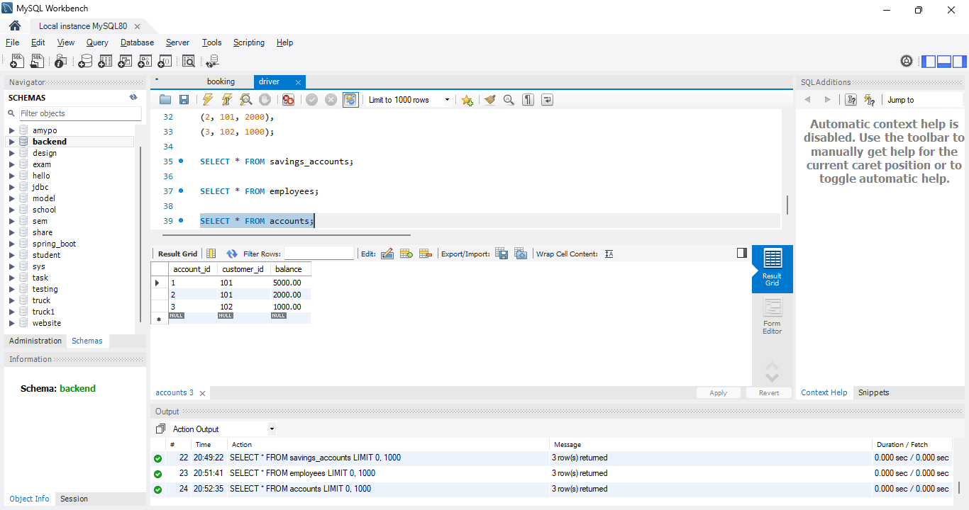

**Mockito exercises**

Exercise 1: Mocking and Stubbing

Coding:

ExternalApi.java

package com.example;

public interface ExternalApi {

String getData();

}

MyService.java

package com.example;

public class MyService {

private final ExternalApi api;

public MyService(ExternalApi api) {

this.api = api;

}

public String fetchData() {

return api.getData();

}

}

MyServiceTest.java

package com.example;

import org.junit.jupiter.api.Test;

import static org.mockito.Mockito.*;

import static org.junit.jupiter.api.Assertions.*;

public class MyServiceTest {

@Test

public void testExternalApi() {

ExternalApi mockApi = mock(ExternalApi.class);

when(mockApi.getData()).thenReturn("Mock Data");

MyService service = new MyService(mockApi);

String result = service.fetchData();

assertEquals("Mock Data", result);

}

}

Output:

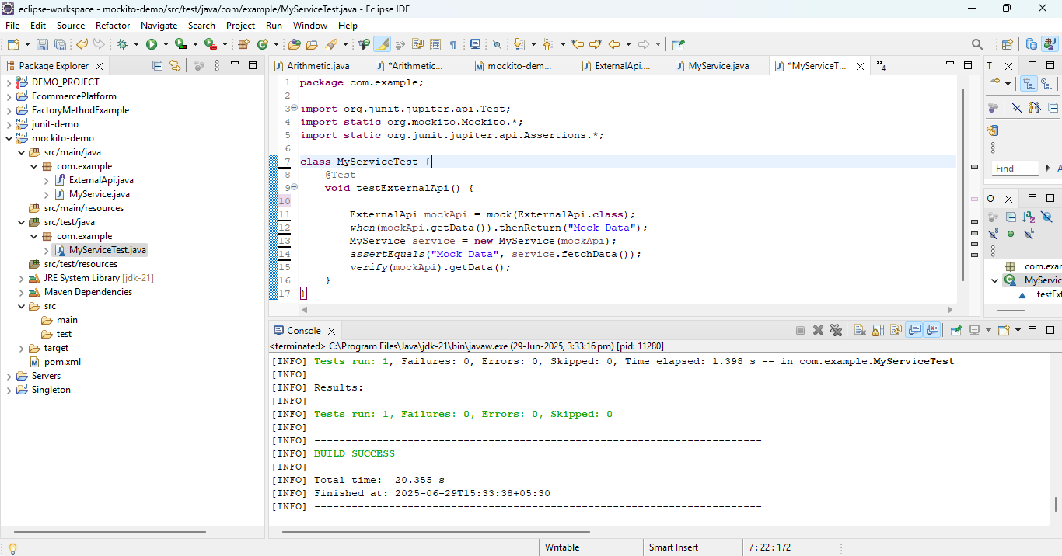

Exercise 2: Verifying Interactions

Coding:

ArithmeticApi.java

**package** com.example;

**public** **interface** ArithmeticApi {

String getData();

}

ArithmeticService.java

package com.example;

public class ArithmeticService {

private final ArithmeticApi api;

public ArithmeticService(ArithmeticApi api) {

this.api = api;

}

public String fetchData() {

return api.getData();

}

}

ArithmeticServiceTest.java

package com.example;

import org.junit.jupiter.api.Test;

import static org.mockito.Mockito.*;

class ArithmeticServiceTest {

@Test

void testVerifyInteraction() {

ArithmeticApi mockApi = mock(ArithmeticApi.class);

when(mockApi.getData()).thenReturn("Mock Data");

ArithmeticService service = new ArithmeticService(mockApi);

service.fetchData();

verify(mockApi).getData();

}

}

Output:

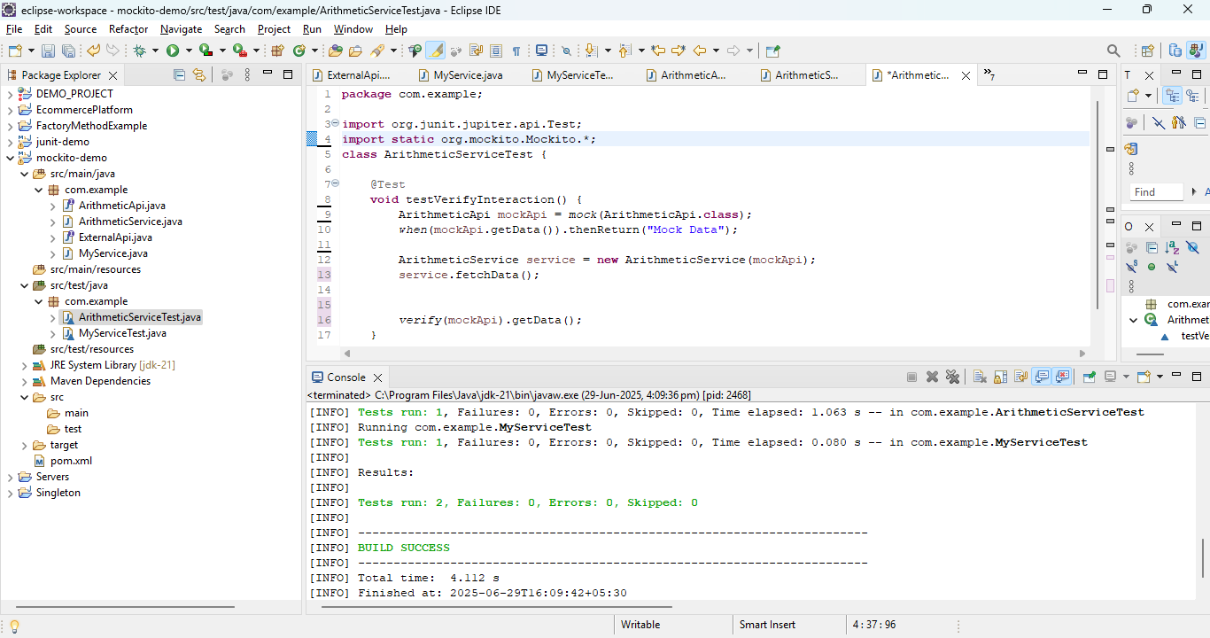

**SLF4J logging framework**

Exercise 1: Logging Error Messages and Warning Levels

Coding:

LoggingExample.java

package com.example;

import org.slf4j.Logger;

import org.slf4j.LoggerFactory;

public class LoggingExample {

private static final Logger logger =

LoggerFactory.getLogger(LoggingExample.class);

public static void main(String[] args) {

logger.error("This is an error message");

logger.warn("This is a warning message");

}

}

Output:

